CS 255 Business Requirements Document

System Components and Design

Purpose
- Provide a web-based system that helps students prepare for their driving tests through online practice exams and behind-the-wheel training.
- Allow customers to register, select a training package, and manage their account online.
- Allow customers to schedule, reschedule, and cancel behind-the-wheel lessons online.
- Support staff scheduling by allowing the secretary to create and manage appointments for customers who call or visit the office.
- Provide internal management and administration tools for the owner and IT officer (account management, access control, reporting).
- Track customer progress including practice test results (score, time taken, status) and lesson notes/comments from instructors.
- Maintain security and accountability using role-based access and tracking of reservation changes (create/modify/cancel).
- Keep training content current by supporting DMV updates/notifications to reflect policy or question changes.

System Background
- DriverPass identified a need for better driver test preparation because many students fail the DMV exam after studying only previous tests.
- The business model combines:
  - Online learning and practice tests, and
  - On-the-road training lessons (scheduled driving sessions).
- The system must support multiple stakeholders and user types, including:
  - Customers (students)
  - Secretary (scheduling support)
  - IT Officer (system administration, security, account resets)
  - Owner/Management (oversight and reporting)
- DriverPass plans to offer multiple training packages (three initial packages) and needs flexibility to disable packages if offerings change.
- Scheduling must coordinate customers, instructors/drivers, cars, and time slots, with accurate records and the ability to change/cancel appointments.
- The company prefers a cloud-based solution to reduce in-house burden for security, backups, and maintenance while still supporting reporting/export needs.
- The system should support the business need to keep content aligned with the DMV by receiving updates/notifications when rules, policies, or sample questions change.

Objectives and Goals
- Provide customers with online classes and practice tests to improve exam readiness.
- Allow customers to schedule, cancel, and modify driving lessons online.
- Support staff scheduling (secretary) and full administrative access (IT officer, owner).
- Ensure accurate scheduling by matching customer + driver + car + time.
- Maintain security via roles/rights, password reset, and account administration.
- Track and report user activity (who created/changed/canceled reservations).
- Support a cloud/web system to reduce internal burden for security and backups.
- Keep training content current with DMV changes via connected updates and notifications.

Requirements

Nonfunctional Requirements

Performance Requirements
- The system shall support simultaneous access by customers and staff without noticeable delays during common tasks (login, scheduling, viewing test results).
- The system shall display customer test progress (status/score/time taken) and lesson history without excessive load times.
- The system shall generate downloadable reports (e.g., activity reports) in a reasonable amount of time for business use.
- The system shall load common pages (dashboard, schedule view, practice test list, and reports) within 3 seconds under normal operating conditions.

Platform Constraints
- The system shall be web-based and hosted in the cloud to reduce DriverPass’s internal responsibility for backups and security management.
- The system shall be accessible from computer and mobile devices.
- The system shall allow users to download/export reports and information for offline review (e.g., Excel), but system data shall not be modified offline to prevent duplicate or conflicting data.
- The system shall use automated daily backups, store backups securely in the cloud, and support restoration of service and data after a system failure.

Accuracy and Precision
- The system shall prevent data redundancy by ensuring records are updated only when online.
- The system shall accurately store and display reservation details including: customer, date/time, assigned driver, and assigned car.
- The system shall record test results precisely (test name, time taken, score, status).

Adaptability
- The system shall allow administrators to disable a package so new customers cannot register for it.
- The system shall be designed so new packages/features can be added in future releases (by developers/analysts as needed).

Security
- The system shall use role-based access control so different users have different permissions (customer, secretary, IT officer, owner).
- The system shall allow customers to reset forgotten passwords automatically.
- The system shall allow the IT officer to reset accounts and block access when needed (e.g., terminated employees).
- The system shall provide audit tracking for reservations (who created, canceled, or last modified a reservation).
- The system shall allow printing/downloading of activity reports to determine responsibility when issues occur.
- The system shall encrypt sensitive data in transit (HTTPS/TLS) and protect stored credentials using hashing.

Functional Requirements
- User Accounts / Roles
  - The system shall support user roles including Customer, Secretary, IT Officer, and Owner.
  - The system shall allow the IT Officer to reset user accounts and disable user access.
  - The system shall allow customers to automatically reset forgotten passwords.
- Packages / Registration
  - The system shall support three training packages: Package 1 (6 hours), Package 2 (8 hours + in-person DMV rules lesson), and Package 3 (12 hours + in-person DMV rules lesson + online class + practice tests).
  - The system shall allow an administrator to disable a package so customers cannot register for it.
  - The system shall collect customer registration information including name, address, phone number, state, and payment card details.
  - The system shall collect pickup and drop-off location for driving lessons (drop-off defaults to pickup).
- Scheduling / Reservations
  - The system shall allow customers to schedule driving lessons online using their accounts.
  - The system shall allow the secretary to schedule driving lessons for customers who call or visit the office.
  - The system shall define each driving lesson session as two hours.
  - The system shall assign each reservation to a specific customer, driver, car, date, and time.
  - The system shall allow customers to cancel and modify appointments online.
  - The system shall prevent double-booking of drivers and cars for overlapping times.
- Online Training / Practice Tests
  - The system shall provide access to online course content and practice tests for customers enrolled in the package that includes online training.
  - The system shall track and display online test progress including test name, time taken, score, and status (not taken, in progress, failed, passed).
- Notes / Reporting / Audit Trail
  - The system shall store and display driver notes and lesson time details (start hour, end hour, comments).
  - The system shall track who created, canceled, and last modified reservations.
  - The system shall generate and allow downloading/printing of activity reports showing user actions.
  - The system shall allow staff to download reports for offline review and analysis (e.g., Excel).
- DMV Updates
  - The system shall connect to DMV updates so DriverPass can keep tests/questions/policies current.
  - The system shall notify DriverPass when DMV rules/policies/sample questions are updated.
- Contact / Communication
  - The system shall include a contact page for customers to reach DriverPass.
  - The system shall support a way for DriverPass to contact students.

User Interface
- The system shall provide a web-based interface usable from desktop and mobile devices.
- The system shall provide a customer dashboard showing:
  - practice test history and progress (status/score/time taken)
  - scheduled lessons and lesson history
  - driver notes associated with lessons
- The system shall provide staff screens for:
  - entering student information via input form
  - scheduling/editing reservations
  - viewing assigned driver/car schedules
- The system shall provide administrative screens for:
  - user/role management (IT Officer)
  - report generation and audit viewing (Owner/IT)

Assumptions
- Users will have internet access when making updates (offline use is limited to viewing/downloaded reports).
- Drivers are associated with specific cars (as described: 10 cars, each car has a driver).
- DMV updates are available in a format the system can receive (API/feed/integration), or an agreed method will be established to deliver notifications.
- Customers who register by phone/office will have their info entered by the secretary.

Limitations
- The system will not support offline editing of records to avoid duplicate/conflicting data.
- Package creation/removal beyond disabling packages may require future development (the owner wants flexibility, but adding/removing modules is stated as a future release discussion).
- DMV integration requirements depend on DMV’s ability to provide updates and the agreed integration approach.

Gantt Chart

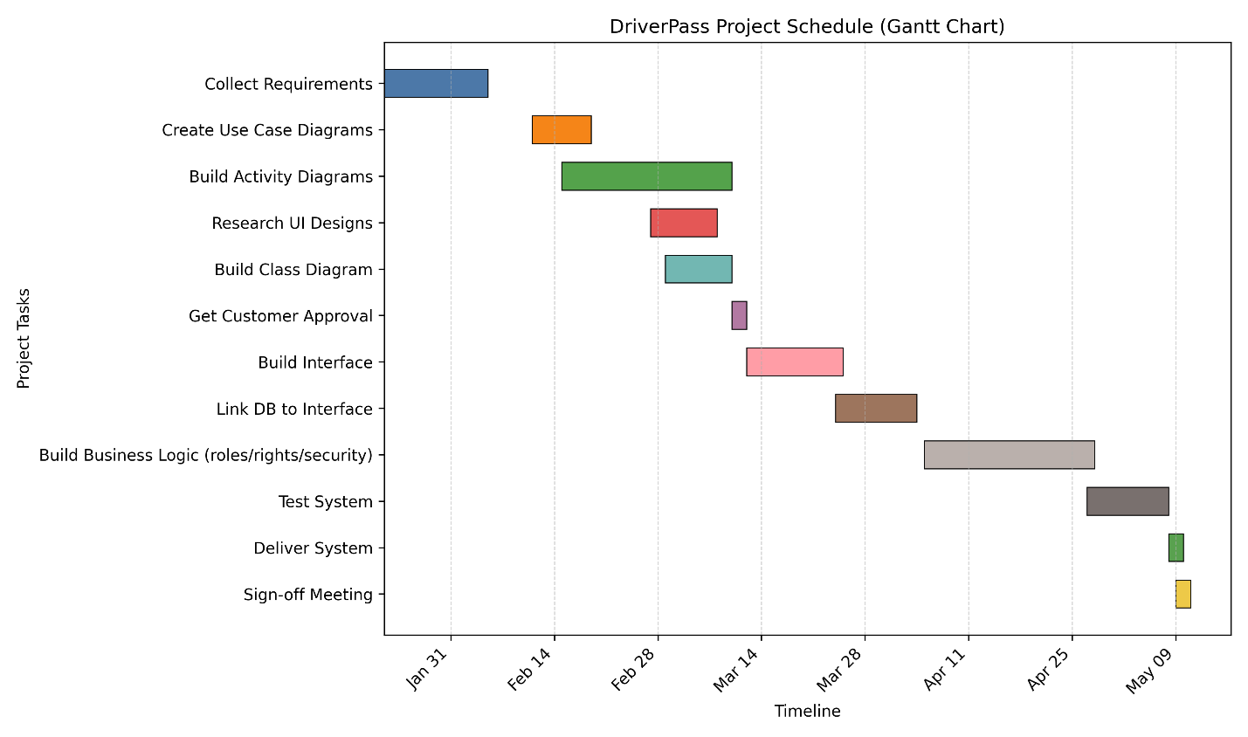
Tasks are sequenced based on dependencies: customer approval must occur before interface development begins; database integration follows interface build; business logic implementation follows integration; and testing occurs after core functionality is completed before delivery and sign-off.

